**103 ROTC**

HAN DUCK SEO, JOO YOUNG CHOI, KANG SU LEE, YOUNG JE WOO, JIN UK LEE

Back then, Wine was regarded expensive and luxury item in korea but it becomes more available these days. Consumers nowadays seems to value the quality assurance tag of each wine. so it becomes important that how the quality of wines is evaluated. wine’s quality is evaluated by chemistry method and sensation method. pH, alcohol, and density is important element of chemistry method. wine is consist of water and alcohol mostly, and the others are sugar, organic acid. I’ll discuss which element makes wine’s quality better and by this analysis, I want to advise consumers which wine is good to drink and high quality.

Date set is extracted from [Cortez et al., 2009] and these are composed of quality of wine and variable to influence on it. There are red wine and white wine data. so we analyze both data.

First, the response variable is the quality of wine, and independent variable is wine's eleven physical-chemical elements(fixed acidity (high settlement), latile acidity (Fi divergence), citric acid (citric acid), residual sugar (residual sugar), chlorides (chloride), free sulfur dioxide (glass sulfur), total sulfur dioxide (before sulfur), density (density), pH (hydrogen ion concentration), sulphates (sulfates), alcohol (alcohol).

In this data set, we are putting the score of the quality of wine from 0 to 10. The rest of the independent variable's observations were judged to be made without stardardization because they are not beyond the excess range.

<Red Wine>

|  |  |  |  |  |  |  |  |  |  |  |  |  |
| --- | --- | --- | --- | --- | --- | --- | --- | --- | --- | --- | --- | --- |
| Red Wine | fixed.  acidity | volatile.  acidity | citric.  acid | residual.  sugar | chlorides | free  sulfur  dioxide | total.  sulfur.  dioxide | density | pH | sulphates | alcohol | quality |
| min | 4.6 | 0.12 | 0 | 0.9 | 0.012 | 1 | 6 | 0.99 | 2.74 | 0.33 | 8.4 | 3 |
| max | 15.9 | 1.58 | 1 | 15.5 | 0.611 | 72 | 289 | 1.003 | 4.01 | 2 | 14.9 | 8 |
| mean | 8.31 | 0.52 | 0.27 | 2.53 | 0.08 | 15.87 | 46.46 | 0.996 | 3.31 | 0.65 | 10.42 | 5.63 |
| median | 7.9 | 0.52 | 0.26 | 2.2 | 0.079 | 14 | 38 | 0.996 | 3.31 | 0.62 | 10.2 | 6 |
| sd | 1.74 | 0.17 | 0.19 | 1.40 | 0.04 | 10.46 | 32.89 | 0.001 | 0.15 | 0.16 | 1.06 | 0.80 |

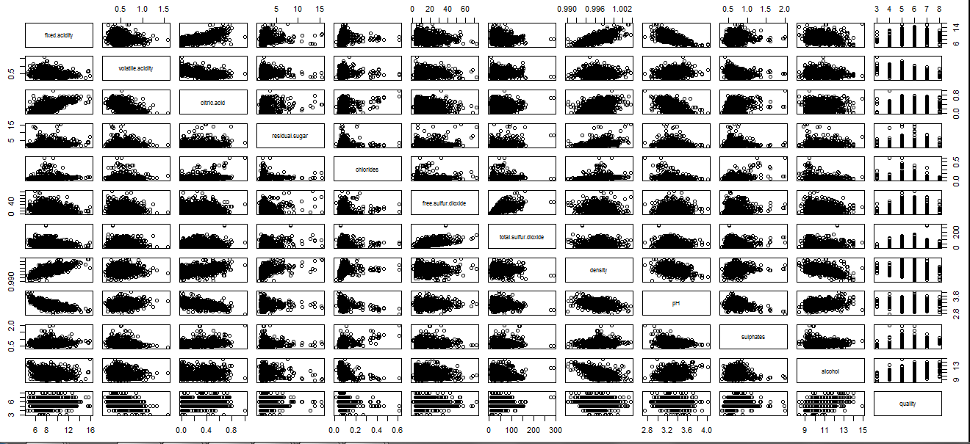

<WhiteWine>

|  |  |  |  |  |  |  |  |  |  |  |  |  |
| --- | --- | --- | --- | --- | --- | --- | --- | --- | --- | --- | --- | --- |
| white Wine | fixed.  acidity | volatile.  acidity | citric.  acid | residual.  sugar | chlorides | free.  sulfur.  dioxide | total.  sulfur.  dioxide | density | pH | sulphates | alcohol | quality |
| min | 3.8 | 0.008 | 0 | 0.6 | 0.009 | 2 | 9 | 0.987 | 2.72 | 0.22 | 8 | 3 |
| max | 14.2 | 1.1 | 1.66 | 65.8 | 0.946 | 289 | 440 | 1.038 | 3.82 | 1.08 | 14.2 | 9 |
| mean | 6.854 | 0.278 | 0.334 | 6.391 | 0.045 | 35.3 | 138.36 | 0.994 | 3.188 | 0.489 | 10.514 | 5.87 |
| median | 6.8 | 0.26 | 0.32 | 5.2 | 0.043 | 34 | 134 | 0.993 | 3.18 | 0.47 | 10.4 | 6 |
| sd | 0.843 | 0.10 | 0.121 | 5.072 | 0.021 | 17.007 | 42.498 | 0.002 | 0.151 | 0.114 | 1.23 | 0.885 |

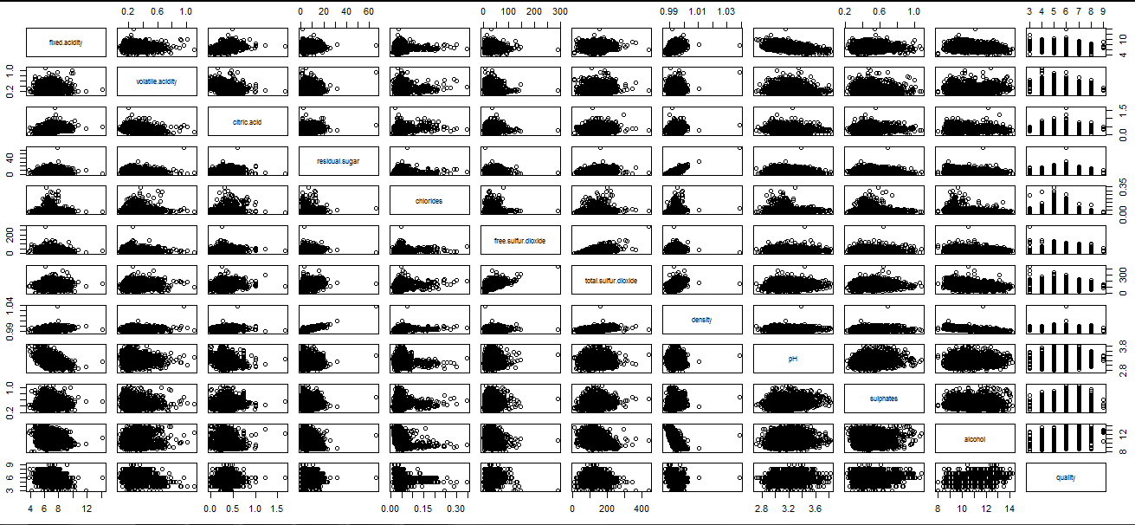

We have a selection of wines physical and chemical data. Therefore, quantification is much more concreter than the other data. The number of Variable is 11, which is many big.

<fixed acidity, latile acidity. citric acid, residual sugar, chlorides, free sulfur dioxide, total sulfur dioxide, density, pH, sulphates, alcohol>

There are mary variables, so we cannot confirm the aspects of this wine data. Therefore, in the final project, we analyze the salient aspect later.

We perform this project thoughout regression, clustering, ridge, and lasso which are methods of analysis.